2023 Applied Maths Ordinary Level paper

2023 OL Question 1 (a)
The diagram below shows a graph with five nodes, 𝐴, 𝐵, 𝐶, 𝐷 and 𝐸.
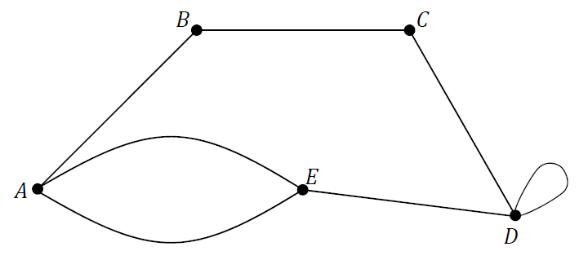

- Write the adjacency matrix for this graph.

- Matrix A = $\left[\begin{matrix}3 & 4 \\ -1 & -2\end{matrix}\right]$ and matrix B = $\left[\begin{matrix}-1 & 2 \\ 0 & 3\end{matrix}\right]$. Calculate AB.

2023 OL Question 1 (b)
Claire is an Applied Mathematics student and she wishes to model the rate at which a block of ice of mass 2 kg will melt.
Claire’s model assumes that the block of ice will lose 8% of its mass through melting every hour.
She calculates the mass (𝑀_{n}) of the solid ice remaining after 𝑛 hours. Some of these values are shown in the table below, to 2 decimal places.

𝑛 (hours) | 𝑛 = 0 | 𝑛 = 1 | 𝑛 = 2 | 𝑛 = 3 | n = 4
𝑀_{n} (kg) | 2.00 | 1.84 | 1.69

- Calculate 𝑀₃, the mass of ice remaining when 𝑛 = 3 hours, and 𝑀₄, the mass of ice remaining when 𝑛 = 4 hours.

According to Claire’s model, the values of 𝑀_{n} are a geometric sequence which may be represented by the difference equation:
𝑀_{n+1} = 0.92𝑀n
where 𝑛 ≥ 0, 𝑛 ∈ ℤ and 𝑀₀ = 2.00 kg.

- Explain how Claire derived this difference equation.

- Calculate the total mass of ice lost through melting when 𝑛 = 6 hours.
- Calculate the smallest value of 𝑛 such that the block of ice has a mass of less than 1 kg.

2023 OL Question 2 (a)
A piece of clay of mass 0.335 kg rests on a horizontal potter’s wheel, which is rotating with period 𝑇 = 1.2 s.
The clay moves with uniform circular motion of radius 𝑟.
The coefficient of friction between the wheel and the clay is ½.
- Draw a labelled diagram to show the forces acting on the clay.
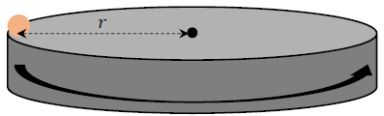
- Calculate the force of friction that acts on the clay.

- Calculate 𝜔, the angular velocity of the clay.
- Calculate the value of 𝑟.

2023 OL Question 2 (b)
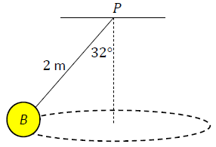
Ball 𝐵, of mass 5.5 kg, is connected to a fixed point 𝑃 by a light inextensible string of length 2 m.
The ball moves in a horizontal circle, where the centre of the circle is vertically below 𝑃.
The string makes an angle of 32° with the vertical, as shown in the diagram.

- Draw a labelled diagram to show the forces acting on 𝐵.

- Calculate the tension in the string.

- Calculate 𝜔, the angular velocity of the ball.

2023 OL Question 3
Two vectors 𝑞⃗ = 6𝚤⃗ + 8𝚥⃗ and 𝑟⃗ = - 4𝚤⃗ + 3𝚥⃗ are shown on the diagram below.
𝑞⃗ makes an angle 𝛼 with the positive direction of the 𝚤⃗ axis and 𝑟⃗ makes an angle 𝛽 with the negative direction of the 𝚤⃗ axis.

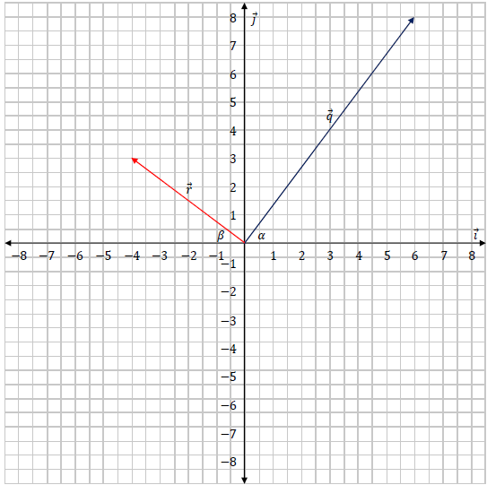

- Calculate 𝑠⃗, where 𝑠⃗ = - ½ 𝑞⃗ - 𝑟⃗.

- Draw 𝑠⃗ on the axes shown.
- Calculate |𝑞⃗| and |𝑟⃗|.

- Calculate 𝛼 and 𝛽.
- Calculate 𝑞⃗. 𝑟⃗, the dot product of 𝑞⃗ and 𝑟⃗.
- Calculate the angle between 𝑞⃗ and 𝑟⃗.

- Calculate the value of 𝑘 and 𝑡 such that 𝑘𝑞⃗ + 𝑡𝑟⃗ = -10𝚤⃗ + 20𝚥⃗.

2023 OL Question 4 (a)
In an effort to become more energy efficient, a university campus invests in upgrading its current heating system.
Each of the five buildings (Arts, Business, Cafeteria,
Design, Engineering) that are on the campus will require connection to this new heating system.
An engineer measures the underground distance, in m, between each of the buildings on the campus grounds.
She presents her results in the table below.

Distance (m) | Arts | Business | Cafeteria | Design | Engineering
Arts | – | 300 | 650 | 525 | 190
Business | 300 | – | 475 | 790 | 210
Cafeteria | 650 | 475 | – | 425 | 145
Design | 525 | 790 | 425 | – | 505
Engineering | 190 | 210 | 145 | 505 | –

- Draw a network to represent this information. On your network the weights of the edges should represent the distances between each of the buildings, which should be represented by labelled nodes.

- To help reduce costs, the engineer must minimise the length of pipework needed for this
heating system.
Using an appropriate algorithm, find the minimum spanning tree for this network. Name the algorithm you used. Relevant supporting work must be shown.

- The pipes used are priced at €525 per metre. In addition, there is an installation cost of €6500 when any two buildings are connected by pipework.
Use your minimum spanning tree to calculate the total cost of this project.

2023 OL Question 4 (b)
Mark is planning to visit South America.
He plans to begin his visit in city 𝐴, and then travel across South America to meet some friends in city 𝐼.
Mark wishes to keep his travel costs to a minimum.
He wishes to calculate the cost of travelling to city 𝐼 by bus, travelling via some of the other cities, 𝐵 to 𝐻.

The cost, in €, of travelling by bus between various cities is shown in the network below. Mark does not intend on visiting all of the cities in his network.

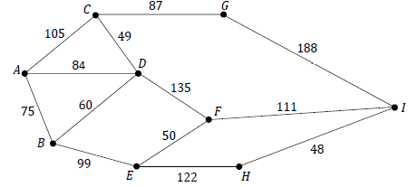

Use Dijkstra’s algorithm to find the cheapest bus route from city 𝐴 to city 𝐼.
Calculate the cost of the cheapest route. Relevant supporting work must be shown.

2023 OL Question 5 (a)
A particle is projected through the air with a velocity of 14𝚤⃗ + 24.5𝚥⃗ m s^{–1} from horizontal ground. The effects of air resistance and wind may be ignored.

- Calculate the time of flight of the particle.
- Calculate the maximum range of the particle.
- Calculate the times when the particle is at a height of 20 m, above the ground.

- The graph below represents the predicted path of this particle when the effects of wind and air resistance are ignored. The graph is not drawn to scale.

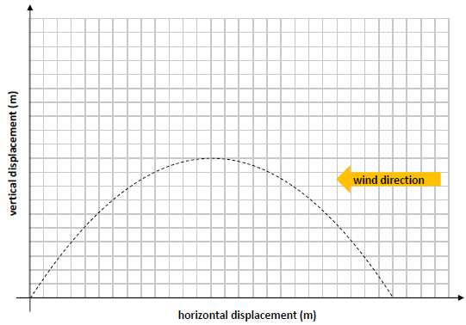
- Using the same axes, sketch the path you would expect the particle to take if the model took into account the effects of wind blowing from the east (but not the effects of air resistance).

2023 OL Question 5 (b)
The algebraic formulae below are written in terms of momentum 𝑝, mass 𝑚, displacement 𝑠 and time 𝑡.
Which of the formulae, X or Y, has the same units as the units for velocity, m s^{–1}?
Use dimensional analysis (comparison of units) to justify your answer.

X: $\sqrt{\frac{2pm}{st}}$ Y: $\sqrt{\frac{2ps}{mt}}$

2023 OL Question 6
A car is parked at a point 𝑃. At time 𝑡 = 0 s the car begins to travel in a straight line with a constant acceleration of 4.5 m s^{–2}. When the car has reached a velocity of 18 m s^{–1} it stops accelerating. The car continues travelling at a velocity of 18 m s^{–1} until 𝑡 = 30 s.
- Calculate the time it takes for the car to reach 18 m s^{–1}.
- Calculate the distance travelled by the car while it is accelerating.
- Calculate the distance travelled by the car when 𝑡 = 30 s.

At 𝑡 = 0 a cyclist passed the car while travelling with a velocity of 8.5 m s^{–1} and an acceleration of 0.5 m s^{–2}. The cyclist accelerated until he reached a velocity of 11 m s^{–1}, which he then maintained.
- Calculate the time taken for the cyclist to reach a velocity of 11 m s^{–1}.
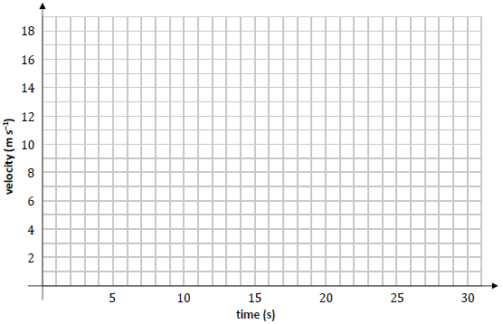
- Using the axes below, draw an accurate velocity‐time graph showing the motion of the car and the motion of the cyclist for the first 30 s of their motion.

- Calculate the distance between the car and the cyclist when 𝑡 = 20 s.

2023 OL Question 7
A small smooth sphere, 𝑆₁, of mass 6 kg is projected with a velocity of 3 m s^{–1} along a smooth horizontal surface and collides with second small smooth sphere, 𝑆₂, of mass 4 kg travelling in the same direction with a velocity of 1.5 m s^{–1}.
The coefficient of restitution between the spheres is $\frac{2}{3}$.

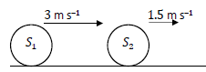

- Calculate the velocity of 𝑆₁ and the velocity of 𝑆₂ after impact.
- Calculate the total kinetic energy of the system before impact.
- Calculate the loss in kinetic energy as a result of the impact.

After the collision, 𝑆₂ travels a distance of 80 cm at constant velocity before it decelerates to rest while travelling a further distance of 50 cm.
- Calculate the time interval between the collision and when 𝑆₂ comes to rest.

2023 OL Question 8 (a)
Kevin takes out a loan of €12 000 to purchase a new car. Kevin will repay the same amount, €𝐴, at the end of each month for 60 months. An interest rate of 0.69% is applied to the amount he owes every month.

𝑈, the amount in € that Kevin owes after 𝑛 months, may be modelled by the difference equation:

U_{n+1} = 1.0069U_{n} - A
where 𝑛 ≥ 0, 𝑛 ∈ ℤ and 𝑈₀ = €12 000

- Solve the difference equation to find an expression for 𝑈􀯡, the amount that Kevin owes after 𝑛 months, in terms of 𝑛 and 𝐴.

- Calculate the value of 𝐴, the repayment made by Kevin at the end of each month, so that the loan is repaid in full after 60 months.

2023 OL Question 8 (b)
Pike is a species of freshwater fish. 𝑃, the population of pike in a certain river, is affected by the level of pollution in the river.
At the start of 2020, the local community attempted to clean up the river and remove the pollution.
To assess if the community was successful, a zoologist measured the population of pike in 2020 and again in 2021.
In 2020 (𝑛 = 0) 8 pike were observed. In 2021 (𝑛 = 1) 14 pike were observed.
The zoologist predicts that the population of pike in any year is equal to twice the population in the previous year plus eight times the population in the year before that. This predication can be expressed as the second‐order difference equation:

P_{n+2} – 2P_{n+1} – 8P_{n} = 0

where 𝑛 ≥ 0, 𝑛 ∈ ℤ, P₀ = 8 and P₁ = 14.

This difference equation has the characteristic quadratic equation 𝑥² - 2𝑥 - 8 = 0.
- Solve this quadratic equation, i.e. calculate the two roots of the equation.
- Hence or otherwise, solve the difference equation to find an expression for 𝑃_{n} in terms of 𝑛.
- Calculate the number of pike that the model predicts will be present in 2026.

2023 OL Question 9 (a)
A student models the motion of a car that is being driven on a rough straight horizontal road on a dry day in June. The car has a mass of 1200 kg. The student carries out some research and estimates that the coefficient of friction, 𝜇, between the car and the dry road is ¼.
The student also finds out that this car has a driving force (tractive force) of 6500 N.
The student models the motion of the car starting from rest.

- Calculate the force of friction that acts on the car while it is moving.
- Calculate the acceleration of the car.
- If the student modelled the motion of this car being driven on the same road in December, explain one refinement that the student might make to the mathematical model.

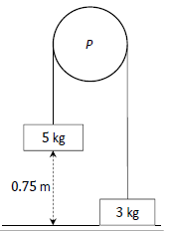
2023 OL Question 9 (b)
A fixed smooth pulley, 𝑃, has blocks of masses 5 kg and 3 kg hanging freely from either side. The blocks are connected by a light inextensible string which passes over the pulley 𝑃.
The 3 kg block is initially at rest on a smooth table and the 5 kg block is held at a distance of 0.75 m above the table, as shown in the diagram.
The system is then released from rest.
- Draw separate diagrams to show the forces acting on the blocks while they are moving.
- Calculate the acceleration of the system.
- Calculate the kinetic energy of the 5 kg block as it hits the table.

2023 OL Question 10
The diagram below shows the scheduling network that an accounting company uses for processing an account. The edges of the network represent the activities that the workers need to carry out when processing an account and are labelled with the letters 𝐴 to 𝐿. The letters used to label the edges should not be taken as representing the order in which the activities happen.
The time, in minutes, to complete each of the activities is shown in brackets.
The nodes of the network represent events or points in time during the processing of an account.
The source node is the time when the processing begins and the sink node is the time when the processing ends.
- Calculate the early time and the late time for each event.

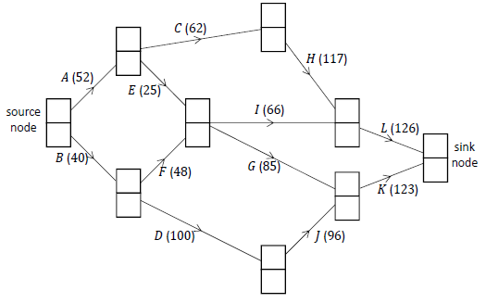
Complete the diagram below by writing the early time (upper box) and late time (lower box) at the node representing each event.

Use the space below and on the next page to show relevant supporting work, if necessary.

- Write down the critical path(s) for the network.

- If the workers begin processing an account at 09: 30 a.m., calculate the earliest time when the work could be completed.

- Calculate the float, in minutes, for activity 𝐼.

- Exactly one hour after the processing of an account has begun, a supervisor checks the work.
State which activity (or activities) must be happening at this time. Justify your answer.

- For a particular account, activity 𝐹 takes twice as long as usual. Does this cause a delay in the processing of the account? Justify your answer.

